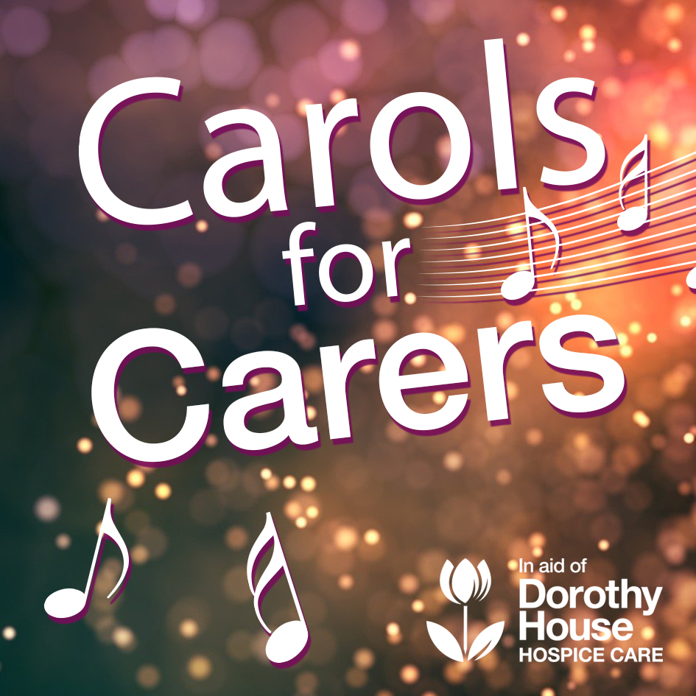

Thursday 17th December 7.00pm

Contents

- Angels From The Realms Of Glory
- Away In A Manger
- Ding Dong Merrily On High
- Good King Wenceslas
- Hark The Herald Angel Sing
- In The Bleak Mid-Winter
- It Came Upon The Midnight Clear
- O Come All Ye Faithful
- Once in Royal David’s City
- Silent Night
- The Twelve Days Of Christmas
- We Three Kings
- While Shepherds Watched
- Gloucestershire Wassail

- Angels From The Realms Of Glory

Angels from the realms of glory,
Wing your flight o’er all the earth;
Ye who sang creation’s story,
Now proclaim Messiah’s birth:
Chorus
Come and worship,
Christ the newborn King.
Come and worship,
Worship Christ, the newborn King!

Shepherds, in the fields abiding,
Watching o’er your flocks by night,
God with man is now residing,
Yonder shines the infant Light;
Sages, leave your contemplations,
Brighter visions beam afar;
Seek the great desire of nations,
Ye have seen His natal star;
Saints before the altar bending,
Watching long in hope and fear,
Suddenly the Lord, descending,
In His temple shall appear:

- Away In A Manger

Away in a manger,
No crib for His bed
The little Lord Jesus
Laid down His sweet head

The stars in the bright sky
Looked down where He lay
The little Lord Jesus Asleep on the hay

The cattle are lowing
The Baby awakes
But little Lord Jesus
No crying He makes

I love Thee, Lord Jesus
Look down from the sky
And stay by my side,
Until morning is nigh.

Be near me, Lord Jesus,
I ask Thee to stay
Close by me forever
And love me I pray

Bless all the dear children
In Thy tender care
And fit us for heaven
To live with Thee there

- Ding Dong Merrily On High

Ding dong merrily on high,
In heav’n the bells are ringing:
Ding dong! verily the sky
Is riv’n with angel singing.
Gloria, Hosanna in excelsis!
E’en so here below, below,
Let steeple bells be swungen,
And “Io, io, io!”
By priest and people sungen.
Gloria, Hosanna in excelsis!
Pray you, dutifully prime
Your matin chime, ye ringers;
May you beautifully rime
Your evetime song, ye singers.
Gloria, Hosanna in excelsis!

- Good King Wenceslas

Good King Wenceslas looked out
On the feast of Stephen
When the snow lay round about
Deep and crisp and even
Brightly shone the moon that night
Though the frost was cruel
When a poor man came in sight
Gath’ring winter fuel
“Hither, page, and stand by me
If thou know’st it, telling
Yonder peasant, who is he?
Where and what his dwelling?”
“Sire, he lives a good league hence
Underneath the mountain
Right against the forest fence
By Saint Agnes’ fountain.”
“Bring me flesh and bring me wine
Bring me pine logs hither
Thou and I will see him dine
When we bear them thither.”
Page and monarch forth they went
Forth they went together
Through the rude wind’s wild lament
And the bitter weather

“Sire, the night is darker now
And the wind blows stronger
Fails my heart, I know not how,
I can go no longer.”
“Mark my footsteps good my page
Tread thou in them boldly
Thou shalt find the winter’s rage
Freeze thy blood less coldly.”

In his master’s steps he trod
Where the snow lay dinted
Heat was in the very sod
Which the Saint had printed
Therefore, Christian men, be sure
Wealth or rank possessing
Ye who now will bless the poor
Shall yourselves find blessing

- Hark The Herald Angel Sing

Hark the herald angels sing
“Glory to the newborn King!
Peace on earth and mercy mild
God and sinners reconciled”
Joyful, all ye nations rise
Join the triumph of the skies
With the angelic host proclaim:
“Christ is born in Bethlehem”

Chorus
Hark! The herald angels sing
“Glory to the newborn King!”

Christ by highest heav’n adored
Christ the everlasting Lord!
Late in time behold Him come
Offspring of a Virgin’s womb
Veiled in flesh the Godhead see
Hail the incarnate Deity
Pleased as man with man to dwell
Jesus, our Emmanuel

Hail the heav’n-born Prince of Peace!
Hail the Son of Righteousness!
Light and life to all He brings
Ris’n with healing in His wings
Mild He lays His glory by
Born that man no more may die
Born to raise the sons of earth
Born to give them second birth
- In The Bleak Mid-Winter

What can I give Him,
Poor as I am?
If I were a shepherd
I would bring a lamb;
If I were a wise man
I would do my part;
Yet what I can, I give Him –
Give my heart.

In the bleak mid-winter
Frosty wind made moan,
Earth stood hard as iron,
Water like a stone;
Snow had fallen, snow on snow,
Snow on snow,
In the bleak mid-winter
Long ago.

Our God, Heaven cannot hold Him
Nor earth sustain;
Heaven and earth shall flee away
When He comes to reign:
In the bleak mid-winter
A stable-place sufficed
The Lord God Almighty,
Jesus Christ.

Enough for Him whom Cherubim
Worship night and dy
Angels and archangels
May have gathered there,
Cherubim and seraphim
Thronged the air –
But only His mother
In her maiden bliss
Worshipped the Beloved
With a kiss.

- It Came Upon The Midnight Clear

It came upon the midnight clear,
That glorious song of old,
From angels bending near the earth,
To touch their harps of gold;
“Peace on the earth, good will to men,
From Heaven’ all gracious King.”
The world in solemn stillness lay,
To hear the angels sing.

Still through the cloven skies they come
With peaceful wings unfurled,
And still their heavenly music floats
O’er all the weary world;
Above its sad and lowly plains,
They bend on hovering wing,
And ever over its Babel sounds
The blessed angels sing.

Yet with the woes of sin and strife
The world has suffered long;
Beneath the angel strain have rolled
Two thousand years of wrong;
And man, at war with man, hears not
The love-song which they bring;
O hush the noise, ye men of strife
And hear the angels sing.

- O Come All Ye Faithful

O Come All Ye Faithful
Joyful and triumphant,
Come ye, O come ye to Bethlehem.
Come and behold Him,
Born the King of Angels;

Chorus:
O come, let us adore Him,
O come, let us adore Him,
O come, let us adore Him,
Christ the Lord.

God of God,
Light of light
Lo He abhors not the virgin’s womb.
Very God
Begotten not created;

Sing, choirs of angels,
Sing in exultation,
Sing all you citizens of heaven above.
Glory to God in the Highest;

- Once In Royal David’s City

Once in royal David’s city,
Stood a lowly cattle shed,
Where a mother laid her Baby,
In a manger for His bed:
Mary was that mother mild,
Jesus Christ, her little Child.

He came down to earth from heaven,
Who is God and Lord of all,
And His shelter was a stable,
And His cradle was a stall:
With the poor, and mean, and lowly,

And our eyes at last shall see Him,
Through His own redeeming love;
For that Child so dear and gentle,
Is our Lord in heaven above:
And He leads His children on,
To the place where He is gone.

Not in that poor lowly stable,
With the oxen standing by;
We shall see him, but in Heaven
Sat at God’s right hand on high;
Where like stars, his children crowned,
All in white shall wait around.

- Silent Night

Silent night, holy night
All is calm, all is bright
Round yon Virgin Mother and Child
Holy Infant so tender and mild
Sleep in heavenly peace
Sleep in heavenly peace

Silent night, holy night!
Shepherds quake at the sight
Glories stream from heaven afar
Heavenly hosts sing Alleluia!
Christ, the Saviour is born
Christ, the Saviour is born

Silent night, holy night
Son of God, love’s pure light
Radiant beams from Thy holy face
With the dawn of redeeming grace
Jesus, Lord, at Thy birth
Jesus, Lord, at Thy birth

- The Twelve Days of Christmas

On the first day of Christmas, my true love sent to me
A partridge in a pear tree.
2 turtle doves
3 French hens
4 calling birds
5 gold rings
6 geese a-laying
7 swans a-swimming
8 maids a-milking
9 ladies dancing
10 lords a-leaping
11 pipers piping
12 drummers drumming

- We Three Kings

We three kings of Orient are
Bearing gifts we traverse afar
Field and fountain, moor and mountains
Following yonder star

Chorus
O Star of wonder, star of night
Star with royal beauty bright
Westward leading, still proceeding
Guide us to thy Perfect Light

Born a King on Bethlehem’s plain
Gold I bring to crown Him again
King forever, ceasing never
Over us all to reign

Frankincense to offer have I
Incense owns a Deity nigh
Prayer and praising, all men raising
Worship Him, God most high

Myrrh is mine, its bitter perfume
Breathes of life of gathering gloom
Sorrowing, sighing, bleeding, dying
Sealed in the stone-cold tomb

Glorious now behold Him arise
King and God and Sacrifice
Heav’n sings Hallelujah
Hallelujah the Earth replies.

- While Shepherds Watched
While shepherds watched
Their flocks by night
All seated on the ground
The angel of the Lord came down
And glory shone around

“Fear not,” he said,
For mighty dread
Had seized their troubled minds
“Glad tidings of great joy I bring
To you and all mankind.”

“To you in David’s Town this day
Is born of David’s line
The Savior who is Christ the Lord
And this shall be the sign.”

Thus spake the seraph,
And forthwith
Appeared a shining throng
Of angels praising God, who thus
Addressed their joyful song

“All glory be to God on high
And to the earth be peace;
Goodwill henceforth
From heaven to men
Begin and never cease!”

14. The Gloucestershire Wassail
Chorus
Wassail! wassail! all over the town,
Our toast it is white and our ale it is brown;
Our bowl it is made of the white maple tree;
With the wassailing bowl, we'll drink to thee.
So here is to Cherry and to his right cheek
Pray God send our master a good piece of beef
And a good piece of beef that may we all see
With the wassailing bowl, we'll drink to thee.
And here is to Dobbin, and to his right eye,
Pray God send our master a good Christmas pie;
And a good Christmas pie that may we all see,
With our wassailing bowl we’ll drink to thee.
Chorus
So here is to Broad May and to her broad horn
May God send our master a good crop of corn
And a good crop of corn that may we all see
With the wassailing bowl, we'll drink to thee.
And here is to Fillpail and to her left ear
Pray God send our master a happy New Year
And a happy New Year as e'er we did see
With our wassailing bowl, we'll drink to thee.
Chorus
Come butler, come fill us a bowl of the best
Then we hope that your soul in heaven may rest
But if you do draw us a bowl of the small
Then down shall go butler, bowl and all.

Then here's to the maid in the lily white smock
Who tripped to the door and slipped back the lock
Who tripped to the door and pulled back the pin
For to let these jolly wassailers in.
Chorus X2

